LESSON - 26
ENERGY METABOLISM: THE PHOTOTROPHS
HASRVEST OP LIGHT ENERGY

A. Objectives

- Explain the two parts of photosynthesis; discuss the physical properties of light and the nature of light-harvesting pigments; explain what it means when chlorophyll or carotenoid “harvest” light energy.
- Explain the energy production of plants; discuss why the pathway is called the Z-scheme; identify the photosystems; trace the origin, flow and final destination of the electrons; write down a summary reaction of photophosphorylation

B. Lecture outline

1. PHOTOSYNTHESIS

2. CAPTURING LIGHT ENERGY

a. the physical nature of light

Read: Light (SBM p192-193)

- light-harvesting pigments

Read: Chloroplasts (SBM p193-196)

a. chlorophylls
b. carotenoids
c. photophosphorylation

3. OXYGENIC PHOTOPHOSPHORYLATION OF PLANTS AND ALGAE: THE Z-SCHEME

Read: Overview of photosynthesis (SBM p196-197)
The light-dependent reactions (SBM p198-201)

C. Study Questions.

1. Radiant energy, including visible light, is propagated as units or
packets of energy called
A. atoms.
B. electrons.
C. photons.
D. pigments.
E. waves.

- C-autotrophs are living organisms that derive all
A. energy from (sun)light.
B. energy from oxidation of chemicals.
C. carbon from organic molecules
D. carbon from inorganic molecules, i.e., carbon dioxide.

3. C-heterotrophs are living organisms that derive all
A. energy from (sun)light.
B. energy from oxidation of chemicals.
C. carbon from organic molecules.
D. carbon from inorganic molecules, i.e., carbon dioxide.

4. What property of the electromagnetic wave determines the intensity of light?
A. amplitude.
B. photon concentration.
C. wavelength.
D. frequency.
E. color.

5. Identify the most energetic electromagnetic waves.
- gamma—rays.
- X-rays.
C. visible light.
D. infrared light.
E. radio waves.

6. Identify the electromagnetic waves of highest frequency?
A. visible light.
B. X-rays.
C. radio waves.
D. infrared light.
E. UV-light.

7. Identify the electromagnetic waves with the longest wavelength.
A. blue light.
B. green light.
C. yellow light.
D. orange light.
E. red light.

8. Compared with light of long wavelength, short wavelength photons have
- about the same amount of energy.
- a different kind of energy.
- energy less available to cells.
- less energy.
- more energy.

9. Identify the light with most energy.
A. 350 nm
B. 450 nm
C. 550 nm
D. 650 nm
E. 750 nm

10. Electromagnetic waves visible to the human eye have wavelengths
A. > 10⁻² m.
B. 10⁻⁴ to 10⁻² m.
c. 10⁻⁴ to 10⁻⁶ m.
D. 10⁻⁶ to 0.3x10⁻⁶ m.
E. < 10⁻⁸ m.

- Molecules that absorb light are called
A. absorbers.
B. chlorophyll.
C. photosynthesizers.
D. reflectors.
E. pigments.

12. The chloroplast pigment beta—carotene is vital to humans, because
A. an excess in the diet can cause liver damage.
B. it can be used directly as a source of energy.
C. it is the main source of vitamin A, which is used in vision.
D. plants use it to attract pollinators.
E. plants use the energy it absorbs to produce food.

13. What description best fits a chlorophyll molecule?
A. a lipophilic macromolecule of membranes composed of a Mg²⁺-containing porphyrin ring and phytol tail.
B. linear molecule characterized by a hydrocarbon chain of alternate single and double bonds.
C. a water-soluble molecule of two phosphate-linked dinucleotides.
D. a transmembrane molecule composed of a catalytic head and proton-conducting tail.
E. a dipolar molecule made of a central oxygen flanked by two hydrogens.

14. What description best fits a carotenoid?
A. a lipophilic macromolecuJ.e of membranes composed of a containing porphyrin ring and phytol tail.
B. linear molecule characterized by a hydrocarbon chain of alternate single and double bonds.
C. a water—soluble molecule of two phosphate-linked dinucleot ides.
D. a transmembrane molecule composed of a catalytic head
and proton-conducting tail.
E. a dipolar molecule made of a central oxygen flanked by two hydrogens.

15. What molecule best fits the electron-transport ATPase?
A. a lipophilic macromolecule of membranes composed of a Mg^{2~}-containing porphyrin ring and phytol tail.
B. linear molecule characterized by a hydrocarbon chain of alternate single and double bonds.
C. a water-soluble molecule of two phosphate-linked dinucleotides.
D. a transmembrane molecule composed of a catalytic head and proton-conducting tail.
E. a dipolar molecule made of a central oxygen flanked by two hydrogens.

16. The source of energy used to generate ATP in the Z scheme is
A. light.
B. water.
C. oxygen.
D. glucose.
E. carbon dioxide.

17. What statement describes best a pigment excited by absorption of light energy?
A. Electrons orbit the atom nuclei at speeds exceeding that of light.
B. The pigment becomes warm and hot and thus more reactive.
C. The outer electrons of the molecule are in a higher, more energy-rich orbit circling the molecules.
D. The pigment molecules become the negatively-charged partner of ionic bonds.
E. The pigment moves from the cytoplasm to the thylakoid membranes of the chloroplasts.

18. When chlorophyll absorbs light an “exited” pigment is generated, that is, the pigment molecules
A. become all nervous, and under the microscope, dance and jump in exaggerated saltatory movements.
B. are converted from very poor electron donors to very good electron donors.
C. glow flusteringly in the dark.
D. transfer the light energy directly to ATP in a process called substrate—level phosphorylation.
E. acquire a more positive reduction potential.

19. What is NOT a requirement of photophosphorylation?
A. Weak electron donors are converted in strong electron donors.
B. Electrons are transported by a membrane-bound electron
transport system.
C. A pH gradient is formed across a membrane.
D. A membrane-bound ATPase exploits the energy of a proton-motive force.
E. Chemical oxidation is the source of the electrons.

20. Photophosphorylation of plants is said to be oxygenic because it
A. reduces oxygen.
B. produces oxygen.
C. occurs in the presence of oxygen.
D. is inhibited anaerobically.
E. is based on oxidation of chemicals.

21. The correct flow of electrons in oxygenic photophosphorylation is
A. glucose → photosystem I → photosystem II →oxygen.
B. oxygen → photosystem II → photosystem I → glucose
C. water → photosystem II → photosystem I __> NAD⁺
D. glucose → glyceraldehyde-3-phosphate → 1,3-diphosphoglycerate → pyruvate.
E. citrate --> alpha-ketoglutarate → succinate → oxalo acetate.

22. What is NOT a product of oxygenic photophosphorylation?
A. oxygen.
B. reduced coenzyme.
C. ATP
D. carbon dioxide.

23. One of the important first results of the light reactions is
A. the addition of phosphate to sugar to form sugar phosphate.
B. the change of chlorophyll from green to colorless.
C. the generation of ATP from the energy of a proton gradient.
D. The rearrangement of sugar molecules to form oxygen and water.
E. the transfer of electrons to glucose molecules.

24. What is the light-harvesting pigment of photosystem I?
A. Accessory pigment.
B. purple pigment.
C. green sulfur.
D. P700.
E. retinal.

25. Identify the light-harvesting pigment of photosystem II?
A. ATP.
B. chlorophyll a.
C. NAD⁺
D. oxygen.
E. P680.

26. In oxygenic photophosphorylation, water is oxidized to provide electrons to replace those ejected from
- P700.
- P680.
- oxygen.
- glucose.
- coenzyme.

27. In oxygenic photophosphorylation, water is split and the oxygen atoms are
- released as oxygen gas.
- combined with organic carbon to form carbon dioxide.
C. incorporated into glucose molecules.
D. combined with hydrogen to form water.
E. passed through an electron transport system.

27. As electrons are passed from photosystem II to photosystem I, energy is released and used to pump protons from the
A. stroma to the thylakoid space.
B. thylakoid space to the stroma.
C. stroma to the space between the inner and outer membrane of the chloroplast envelope.
D. stroma to the cytoplasm.
E. cytoplasm to the space between the inner and outer membrane of the chloroplast envelope.

- Plants are green because they
A. absorb yellow and green light.
B. reflect yellow and blue light.
C. reflect most of the green light.
D. absorb green light.
E. reflect blue and red light.

29. The process by which light energy is converted into the stored chemical energy of organic molecules is:

A. photosynthesis.
B. respiration.
C. diffusion.
D. fermentation.
E. None of these.
30. What is the correct sequence of wavelengths (beginning with the shortest)?

A. gamma rays, UV, x-rays, infrared, visible light, TV and radio waves, and microwaves
B. TV and radio waves, microwaves, visible light, UV, infrared, x-rays, and gamma rays
C. microwaves, gamma rays, UV, visible light, infrared, TV, radio waves, and x-rays
D. gamma rays, x-rays, UV, visible light, infrared, microwaves, TV and radio waves
E. gamma rays, x-rays, UV, infrared, visible light, microwaves, and TV and radio waves

31. Light behaves not only as waves, but also as particles, which are referred to as:

A. electrons.
B. protons.
C. photons.
D. radiation.
E. neutrons.

32. An electron absorbs a photon of light energy and becomes energized; the electron shifts from a ____________ atomic orbital to a _____________ atomic orbital.

A. high energy; low energy
B. fluorescing; ground state
C. ground state; low energy
D. low energy; high energy
E. None of the answer choices are correct.
33. Electrons that are excited to a higher energy level may be transferred to an electron acceptor or may return to a ground state. If the latter occurs, energy will be released in a process known as:

A. photoelectron degradation.
B. fluorescence.
C. photoelectron hydrolysis.
D. porphyrin.
E. photoelectron deconfiguration.

34. Chlorophyll consists of a porphyrin ring that contains a single atom of:

A. manganese.
B. magnesium.
C. phosphorus.
D. nitrogen.
E. iron.
35. Chlorophyll molecules are attached to thylakoid membranes by:

A. a long hydrophobic tail.
B. the porphyrin ring.
C. the methyl group.
D. a magnesium ion.
E. a hydroxide group.

36. Chlorophyll and accessory photosynthetic pigments are associated with the:

A. stroma.
B. thylakoid membranes.
C. mesophyll membranes.
D. light reaction centers of the stroma lamellae.
E. stroma grana.

37. By definition, substances that absorb visible light are called:

A. porphyrins.
B. nucleotides.
C. hydrocarbons.
D. pigments.
E. photons.

38. The most important photosynthetic pigment(s) is(are):

A. carotenoids.
B. xanthophylls.
C. chlorophyll a.
D. chlorophyll b.
E. All of these are equally important for photosynthesis.

39. The ____________________ of a chlorophyll molecule is (are) responsible for absorbing light.

A. carbon atoms
B. porphyrin ring
C. methyl group
D. magnesium ion
E. long hydrophobic tail

40. A group of thylakoid discs make up:

A. the stroma.
B. a granum.
C. a chloroplast.
D. a vacuole.
E. the mesophyll layer.

41. In a chloroplast, there is an outer and an inner membrane. The inner membrane encloses a fluid filled region called the:

A. grana.
B. thylakoid.
C. stroma.
D. pigment.
E. electron acceptor.

42. The thylakoid membrane encloses a space called the:

A. lumen.
B. stroma.
C. granum.
D. mesophyll.
E. porphyrin.

43. Thylakoid membranes are involved in _____ synthesis.

A. glucose
B. NADP
C. ATP
D. RuBP
E. PEP

44. Chlorophyll:

A. reflects red and blue light, and absorbs green light.
B. transmits red and blue light, and absorbs green light.
C. transmits red and blue light, and reflects green light.
D. absorbs red and blue light, and reflects green light.
E. absorbs red, blue, and green light.

45. Accessory photosynthetic pigment that expands the spectrum of light that provides energy for photosynthesis:

A. carotenoids.
B. chlorophyll a.
C. chlorophyll b.
D. Both caroternois and chlorophyll a.
E. Both carotenoids and chlorophyll b

46, 47. Use the figure to answer the corresponding questions.

46, Chloroplasts will be found in the greatest density in the area of the figure labeled:

A. 1 and 2.
B. 3 and 4.
C. 4 and 5.
D. 6 and 7.
E. 7 and 8.

47. The primary function of the leaf structure labeled 5 in the figure is:

A. food storage.
B. photosynthesis.
C. water transportation.
D. gas exchange.
E. nutrient absorption.

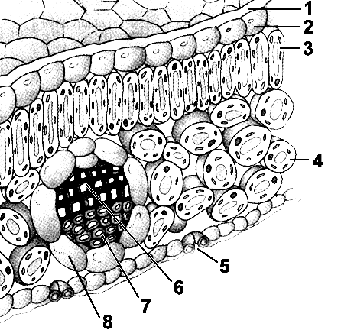

48. The action spectrum of photosynthesis best matches the absorption spectrum of:

A. NADPH.
B. carotenoids.
C. chlorophyll.
D. xanthophylls.
E. anthocyanin.

49, 50. Use the figure to answer the corresponding questions.

49. According to the accompanying graph, chlorophyll absorbs light most strongly in the:

A. red and blue wavelengths.
B. blue and green wavelengths.
C. green and yellow wavelengths.
D. UV and red wavelengths.
E. UV and infrared wavelengths.

50. The graph in the accompanying figure represents the:

A. electromagnetic spectrum.
B. action spectrum of photosynthesis.
C. absorption spectra for chlorophylls a and b.
D. Z scheme for photosynthesis.
E. None of these.

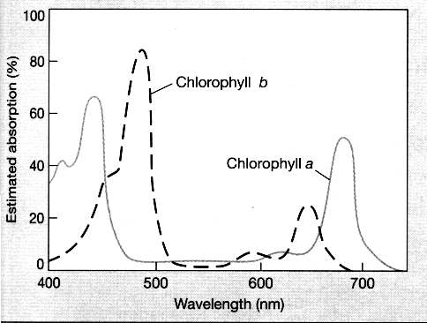

51. Chlorophyll absorbs primarily _____ and _____ regions of the visible spectrum.

A. blue; red
B. green; yellow
C. red; green
D. red; yellow
E. blue; yellow

52. Red and blue light support the highest rates of photosynthesis because:

A. these are the only wavelengths reaching Earth from the sun.
B. these are the only wavelengths that carotenoids cannot absorb.
C. these wavelengths have the highest energy in the visible spectrum.
D. chlorophyll absorbs these wavelengths more than other wavelengths.
E. these wavelengths activate the ATP sythetase enzyme.

53. Engelmann concluded that chlorophyll in the chloroplasts is responsible for photosynthesis based on the following results:

A. Spirogyra cells each contain a long, spiral-shaped, emerald-green chloroplast embedded in the cytoplasm.
B. The action spectrum of photosynthesis matched the maximum production of oxygen by Spirogyra, observed by the greatest accumulation of bacteria in the blue and red regions of the spectrum.
C. Bacteria exposed to the action spectrum for photosynthesis showed no preference to any particular color of light.
D. Accessory pigments transfer some of the energy of excitation produced by green light to chlorophyll molecules.
E. None of these answer choices is correct.

54. The overall reactions of photosynthesis are best summarized as:

A. 12 CO₂ + 6 H₂O → C₆H₁₂O₆ + 12 O₂ + 6 H₂O.
B. C₆H₁₂O₆ + 6 O₂ + 6 H₂O → 6 CO₂ + 12 H₂O.
C. 6 CO₂ + 12 H₂O → C₆H₁₂O₆ + 6 O₂ + 6 H₂O.
D. 6 CO₂ + 12 H₂O → C₆H₁₂O₆ + 12 O_{2.}
E. 6 H₂CO₃ + 6 H₂O → C₆H₁₂O₆ + C₆H₁₂O₆ + 6 H₂O + 6 O₂.

55. During the reactions of photosynthesis, ____________ is reduced and ____________ is oxidized.

A. O₂; C₆H₁₂O₆
B. CO₂; C₆H₁₂O₆
C. H₂O; C₆H₁₂O₆
D. O₂; H₂O
E. CO₂; H₂O

56. In the overall reactions of photosynthesis, it appears that hydrogen atoms are transferred from water to carbon dioxide to form a carbohydrate. This type of reaction is classified as:

A. a redox reaction.
B. an anaerobic reaction.
C. a catabolic reaction.
D. an oxidation reaction.
E. a hydrolytic reaction.

57. The reactions of photosynthesis are divided into two categories:

A. light-independent reactions and carbon fixation reactions.
B. carbon fixation reactions and oxygen fixation reactions.
C. light-dependent reactions and carbon fixation reactions.
D. light-dependent reactions and citric acid cycle.
E. chemiosmosis and photochemical reactions.

58, 59. Use the figure to answer the corresponding questions.

58. Carbon is fixed in which part of the associated diagram?

A. A
B. G
C. 4
D. 2
E. 1

59. Where in this figure is NADPH formed?

A. F
B. 4
C. 3
D. 2
E. B

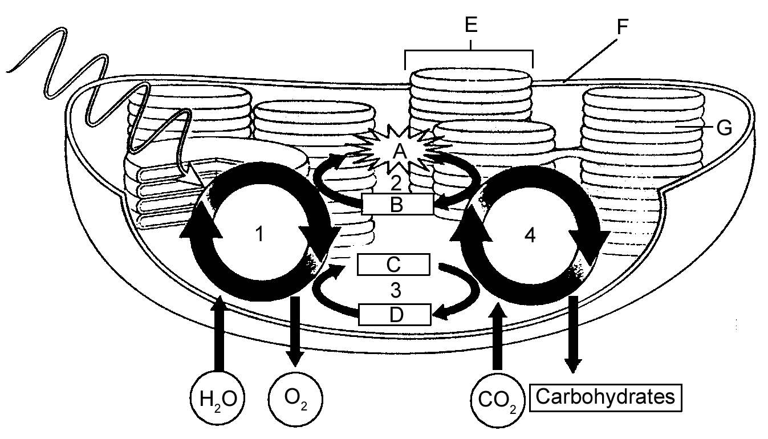

60. In photosynthesis, ATP and NADPH are produced during:

A. the carbon fixation reactions.
B. the light-dependent phase.
C. the light-independent phase.
D. glycolysis.
E. photolysis.
61. The reactions that occur in the thylakoid membranes are:

A. the energy-releasing reactions.
B. the photorespiration reactions.
C. the sugar-producing reactions.
D. the carbon fixation reactions.
E. the light-dependent reactions.

62. The reactants of the light-dependent reactions are:

A. H₂O, ADP, and NADP+.
B. CO₂, ADP, and NADP+.
C. H₂O, ATP, and NADPH.
D. CO₂, ADP, and NADPH.
E. H₂O, CO₂, and NADP+.

63. The reactants of the Calvin cycle are:

A. H₂O, ATP, and NADPH.
B. CO₂, ADP, and NADP+.
C. CO₂, ATP, and NADPH.
D. H₂O, ATP, and NADPH.
E. CO₂, H₂O, and ATP.

64. Which of the following is not associated with the thylakoid membranes?

A. photosystems I and II
B. the Calvin cycle
C. electron transport chain
D. ATP synthase
E. antenna complex

65. 12 H₂O + 12 NADP⁺ + 18 ADP + Pi → 6 O₂ + 12 NADPH + 18 ATP summarizes the ____________ reactions of photosynthesis.

A. carbon fixation
B. light-dependent
C. light-independent
D. CAM
E. electron transport

66. The electron transport chain of photosynthesis is located in the:

A. cristae.
B. mitochondria.
C. outer chloroplast membrane.
D. chloroplast stroma.
E. thylakoid membrane.

67. Reaction center complexes of the light-dependent reactions contain ____________ and ____________, which receive energy from ____________.

A. accessory pigments; chlorophyll; antenna complexes
B. carotenoids; proteins; chlorophyll
C. chlorophyll; antenna complexes; carotenoid
D. proteins; antenna complexes; carotenoid
E. chlorophyll; proteins; antenna complexes

68. How many electrons are needed to reduce one molecule of NADP⁺ to NADPH?

A. 1
B. 2
C. 3
D. 4
E. 5

69. During the light-dependent reactions of photosynthesis, a constant supply of electrons is provided by:

A. water.
B. oxygen.
C. the sun.
D. chlorophyll.
E. carotenoids.

70. The electrons lost by the P680 reactive center are replaced from:

A. a water molecule.
B. solar energy.
C. ATP.
D. NADP⁺.
E. Photosystem II.

71. Oxygen produced by photosynthesis comes directly from:

A. light.
B. CO₂.
C. glucose.
D. H₂O.
E. ATP.

72. Noncyclic electron transport needs a constant supply of electrons. These are obtained from:

A. light.
B. CO₂.
C. glucose.
D. H₂O.
E. ATP.

73. ATP is formed when __________________ the thylakoid lumen.

A. hydrogen ions enter
B. hydrogen ions leave
C. electrons enter
D. electrons leave
E. water is split in

74. The synthesis of ATP as a result of the light-dependent reactions of photosynthesis is an ____________ reaction that is coupled to the diffusion of ____________ down their concentration gradient.

A. endergonic; protons
B. energy-releasing; hydrogen ions
C. exergonic; electrons
D. energy-acquiring; electrons
E. oxidation; water

75. The synthesis of ATP during photosynthesis or respiration occurs as a result of:

A. phosphorylation of AMP.
B. phosphorylation of ATP.
C. phosphorylation of ADP.
D. phosphorylation of G3P.
E. oxidation of NADPH.

76. The first step in the Calvin cycle is the attachment of carbon dioxide to:

A. Rubisco.
B. glyceraldehyde 3-phosphate (G3P).
C. phosphoglycerate
D. RuBP (ribulose bisphosphate).
E. None of the above.

77. Which of the following is not common to both photosynthesis and aerobic respiration?

A. ATP synthesis
B. electron transport chain
C. oxidation
D. terminal electron acceptor
E. None of these; all are shared by both processes.

78. Which of the following is common to both photosynthesis and aerobic respiration?

A. NADP⁺ and NADPH
B. glycolysis
C. chemiosmosis
D. CO₂ and O₂ as end products
E. thylakoids

79. Where is chlorophyll located in the chloroplast?
A. thylakoid membranes
B. stroma
C. matrix
D. thylakoid lumen
E. between the inner and outer membranes

80. In photolysis, some of the energy captured by chlorophyll is used to split
A. CO2
B. ATP
C. NADPH
D. H2O
E. both b and c

81. Light is composed of particles of energy called
A. carotenoids
B. reaction centers
C. photons
D. antenna complexes
E. photosystems

82. The relative effectiveness of different wavelengths of light in photosynthesis is demonstrated by
A. an action spectrum
B. photolysis
C. carbon fixation centers
D. photoheterotrophs
E. an absorption spectrum

83. In plants, the final electron acceptor in noncyclic electron flow is
A. NADP+
B. CO2
C. H20
D. O2
E. G3P

84. Most plants contain, in addition to chlorophyll, accessory photosynthetic pigments such as
A. PEP
B. G3P
C. carotenoids
D. PGA
E. NADP+

85. The part of a photosystem that absorbs light energy is its
A. antenna complexes
B. reaction center
C. terminal quinine electron acceptor
D. pigment-binding protein
E. thylakoid lumen

86. In __________________, electrons that have been energized by light contribute their energy to add phosphate to ADP, producing ATP.
A. crassulacean acid metabolism
B. the Calvin cycle
C. photorespiration
D. C4 pathways
E. photophosphorylation

87. In ___________________, there is a one-way flow of electrons to NADP+, forming NADPH.
A. crassulacean acid metabolism
B. the Calvin cycle
C. photorespiration
D. cyclic electron transport
E. noncyclic electron transport

88. The mechanism by which electron transport is coupled to ATP production by means of a proton gradient is called
A. chemiosmosis
B. crassulacean acid metabolism
C. fluorescence
D. the C3 pathway
E. the C4 pathway

89. In photosynthesis in eukaryotes, the transfer of electrons through a sequence of electron acceptors provides energy to pump protons across the
A. chloroplast outer membrane
B. chloroplast inner membrane
C. thylakoid membrane
D. inner mitochondrial membrane
E. plasma membrane

