LESSON – 10
METABOLISM AND BIOLOGICAL CATALYSTS.

A. Objectives.

— Define: metabolism, anabolism and catabolism, endergonic and exergonic reactions, substrate, product, enzyme, active center, pH optimum, activator, inhibitor, allosteric effect, cofactor, coenzyme, prosthetic group or co—factor.
- Explain in word and figure activation energy; define the role of a catalyst; explain the function of an enzyme and relate the structure of an enzyme to its function; discuss why enzymes are substrate—specific; explain the statement: “a cell must possess almost as many different kinds of enzymes as it has reactions to catalyze.”
- Explain how an enzyme can be regulated and how it can be affected by its environment; what are allosteric effectors?, conformation of a protein?; discuss the concept of allosteric regulation;
- Give the structure of a generic biochemical pathway; predict the result when an enzyme of the pathway becomes inactivated, or activated; under which conditions do you expect regulation by negative feedback? positive feedback?

B. Lecture outline.

- METABOLISM

Read: Energy and metabolism (SBM p155-157)

a. anabolism and catabolism.
b. endergonic and exergonic reactions.

2. ACTIVATION ENERGY.

Read: Enzymes (SBM p160-167).

a. activation energy:
b. catalysts, catalyzed reactions:

3. NATURE OF ENZYMES.

a. How enzymes work: active center.
b. enzyme specificity.
c. coenzymes, cofacors.

2. FACTORS AFFECTING ENZYME ACTIVITY: regulation.

a. Factors affecting enzyme activity: Temperature, pH, and salts

b. regulation of enzyme activity: Enzyme inhibition.
3. BIOCHEMICAL PATHWAYS.

LESSON-11
ENZYMES AND KINETICS.

A. Objectives.

- Describe graphically for a catalyzed and noncatalyzed reaction how reaction rates change with substrate concentration; what is the name of the function that describes the kinetics of an enzyme— catalyzed reaction?; Explain why enzyme—catalyzed reactions are saturated at high substrate concentrations; define Michaelis—Menten kinetics; what is the relationship between v and S in MichaelisMenten kinetics?; discuss the kinetics of a catalyzed reaction at different substrate concentrations; what is the meaning of Vmax and Kin?
- Explain how an enzyme can be regulated and how it can be affected by its environment; what are allosteric effectors?, conformation of a protein?; discuss the concept of allosteric regulation;
- Give the structure of a generic biochemical pathway; predict the result when an enzyme of the pathway becomes inactivated, or activated; under which conditions do you expect regulation by negative feedback? positive feedback?

B. Lecture outline.

1. ENZYME KINETICS.

a. Michaelis-Menten kinetics.
b. The meaning of Vmax and Km.

2. FACTORS AFFECTING ENZYME ACTIVITY: regulation.

a. Factors affecting enzyme activity:
- temperature:
- pH:

b. regulation of enzyme activity.
- Enzyme inhibition.

3. BIOCHEMICAL PATHWAYS.
Read: Biochemical pathways: the organizational units of metabolism (R&J p155-156).

a. structure of a biochemical pathway.
b. feedback inhibition or negative regulation.

C. Study Questions.

- Reactions that consume energy are said to be
- endergonic.
- endocytotic.
- exergonic.
- exophtalmic.
- xerogonic.

2. Reactions that yield energy are said to be
A. endergonic.
B. endocytotic.
C. exergonic.
D. exophtalmic.
E. xerogonic.

3. Even reactions that release energy may require an input of energy to start. This energy is called
A. electronic bond energy.
B. enthalpy.
C. exergonic energy.
D. activation energy.
E. positive free energy.

4. Substances that can stress chemical bonds in such a way as to reduce activation energy are known as
A. activators.
B. catalysts.
C. endergonic compounds.
D. energy barriers.
E. reactants.

5. In living material, reactions are speeded up as activation energy is lowered by means of
A. ATP and NAD.
B. carbonic acid.
C. enzymes.
- free energy from other reactions.
- inorganic catalysts.

6. Compare the breakdown of carbonic acid into water and carbon dioxide in the presence and absence of the enzyme. In the absence of enzyme the reaction
A. never occurs
B. proceeds in the opposite direction.
C. occurs very slowly because there is appreciable activation energy.
D. proceeds at a reasonable rate but only at high temperatures.
E. occurs very rapidly.

7. In the presence of the enzyme carbonic anhydrase, carbon dioxide and water combine to form carbonic acid. The enzyme reaction occurs
A. never.
B. always in the opposite direction.
C. very slowly because there is appreciable activation energy.
D. at a reasonable rate at high temperatures.
E. quite rapidly because the activation energy is lowered.

8. What is the nature of an enzyme? An enzyme is a
A. nucleic acid.
B. lipid.
C. glycolipid.
D. polysaccharide.
E. protein.

9. When the substrate(s) is(are) bound to the enzyme, the shape of the enzyme may change slightly, leading to
A. a better induced fit.
B. a greater range of possible catalytic activities.
C. a greater supply of activation energies.
D. more permanent binding through intimate total contact.
E. more possible products of the reaction.

10. Enzymes are very specific in their choice of substrates, because each different enzyme has an active site that
A. depends upon the presence of unusual amino acids not common in proteins.
B. has a certain unique amino acid to fit each substrate.
C. is shaped to fit a certain substrate molecule.
D. is lined with glycolipids.
E. increases the temperature of the bound substrate.

11. Most mammalian enzymes operate optimally in a temperature range from
A. -ito 1C.
B. OtolOC.
C. iOto2OC.
D. 35to40C.
E. 80 to 100 C.

12. The pH optimum of most enzymes is
A. less than pH 2.0.
B. pH 2.0 to pH 4.0.
C. around pH 5.0
D. pH 6.0 to pH 8.0.
E. pH 11 to pH 13.

13. Many enzymes require cofactors to function. Which is not a cofactor?
A. carbon.
B. magnesium.
C. calcium
D. molybdenum.
E. copper.

14. What nucleotide is the energy currency of the living material?
A. AND.
B. ATP.
C. DNA.
D. NAD.
E. AMP.

15. ATP releases energy when it is converted to
A. DNA.
B. NADP.
C. NADH.
- ADP.
- AMP.

16. When a high-energy bond of ATP is broken, the amount of energy released equals
A. 0 kcal per mole.
B. less than 1 kcal per mole.
C. 1—2 kcal per mole.
D. 7 kcal per mole.
E. 686 kca]. per mole.

17. An allosteric regulator of enzyme activity
A. acts as an electron acceptor.
B. changes the shape of the enzyme.
C. combines with the enzyme at the active site.
D. combines with the substrate at the active site.
E. releases the product from the active site.

18. What happens to the enzyme at the conclusion of the enzyme reaction? The enzyme
A. must be resynthesized from amino acids.
B. frees itself from the product and is ready to be reused.
C. It must be reactivated by the addition of activation energy.
D. changes its shape into an inactive form.
E. closes its active site so that no more substrate can bind.

19. The main components of ATP are
A. adenine, ribose, phosphates.
B. adenine, sugars, phosphates, nicotinamide.
C. amino acids, coenzymes, activators.
D. carbon dioxide, oxygen and water.
E. glycerol, phosphate, fatty acids.

20. What is the proper name for the substance that is changed by enzyme activity?
A. active site.
B. substrate.
C. polypeptide.
D. coenzyme.
E. allosteric effect.

21. What is the name for the site of the enzyme where substrate binds and product is formed?
A. active site.
B. substrate.
C. polypeptide.
D. coenzyme.
E. allosteric effect.

22. What is the name for the non-protein, organi.c part of an enzyme?
A. active site.
B. substrate.
C. polypeptide.
D. coenzyme.
E. allosteric effect.

23. How do you characterize the reaction: ATP --> ADP + P_{I}?
A. endergonic reaction.
B. exergonic reaction.
C. hydrolytic reaction.
D. dehydration reaction.
E. condensation reaction.
F. both B and C.

24. Enzymes are affected by several factors such as
A. temperature.
B. pH.
C. amount of substrate.
D. inhibitors.
E. all of the above.

25. The relationship between the concentration of a substrate and the rate of an enzyme—catalyzed reaction is
A. linear, regardless of the concentration of substrate.
B. inversely linear.
C. linear up to a maximum substrate concentration and then constant.
D. exponential.
E. none of the above.

- Which of the following statements is true for enzymes?
A. The more an enzyme is heated, the more active it becomes.
B. Enzymes are composed of monosaccharides.
C. Enzymes are unaffected by the concentration of hydrogen ions.
D. An enzyme’s activity depends on its three dimensional structure.
E. An enzyme determines which type of chemical reactions can occur between two chemicals.

27. The active site of an enzyme is
A. unaffected by pH.
B. the site of binding of allosteric regulator molecules.
C. determined by the primary structure of the enzyme protein.
D. not affected by the temperature. E. the site of storage of energy.

28. In the Michaelis-Menten equation of an enzyme reaction, v denotes
A. substrate concentration.
B. initial reaction velocity.
C. affinity constant.
D. Michaelis-Menten constant.
E. maximum (reaction) velocity.

28. In the Michaelis-Menten equation of an enzyme reaction, Km denotes
A. substrate concentration
B. initial reaction velocity.
C. affinity constant.
D. Michaelis-Menten constant.
E. maximum (reaction) velocity.
F. Both C and D.

28. In the Michaelis-Menten equation of an enzyme reaction, S denotes
A. substrate concentration,
B. initial reaction velocity.
C. affinity constant.
D. Michaelis—Menten constant.
E. maximum (reaction) velocity.

28. In the Michaelis-Menten equation of an enzyme reaction, Vmax denotes
A. substrate concentration,
B. initial reaction velocity.
C. affinity constant.
D. Michaelis-Menten constant.
E. maximum (reaction) velocity.

29. The Michaelis-Menten reaction states that v equals
A. S/(Vmax.Km)
B. (Km+S)/Vmax.S)
C. (Vmax.S)/(Km+S)
D. (Vmax.Km)/S
E. Vmax/(Km.S)

30. In the Michaelis—Menten equation, (Vmax.S)/(Km+S) equals the
A. initial reaction velocity.
B. substrate affinity.
C. Michaelis—Menten constant.
D. maximum velocity.
E. substrate concentration at half-maximal velocity.

- When the initial reaction velocity of an enzyme reaction is plotted in function of the substrate concentration, the resulting line is
A. linear.
B. exponential.
C. parabolic.
D. hyperbolic.
E. ellipsoid.

32. At very high substrate concentrations
A. reaction velocity remains constant.
B. reaction velocity is independent of substrate concentration.
C. reaction velocity is proportional to enzyme concentration.
D. the enzyme is saturated.
E. all of the above.

33. At substrate concentrations much smaller than the Km value the reaction velocity
A. increases quasi-linearly with substrate concentration.
B. is half that of the maximal reaction velocity.
C. is independent of substrate concentration.
D. increases logistically with substrate concentration.
E. increases exponentially with substrate

34. At substrate concentration equal to the Km value the reaction velocity
A. increases quasi-linearly with substrate concentration.
B. is half that of the maximal reaction velocity.
C. is independent of substrate concentration.
D. increases logistically with substrate concentration.
E. increases exponentially with substrate

35. At substrate concentrations that equal the affinity constant of the enzyme the reaction velocity
A. increases quasi-linearly with substrate concentration.
B. is half that of the maximal reaction velocity.
C. is independent of substrate concentration.
D. increases logistically with substrate concentration.
E. increases exponentially with substrate

36. At substrate concentrations much higher than the Km value the reaction velocity
A. increases quasi—linearly with substrate concentration.
B. is half that of the maximal reaction velocity.
C. is independent of substrate concentration.
D. increases logistically with substrate concentration.
E. increases exponentially with substrate

- The Michaelis-Menten constant of an enzyme for a substrate measures
- the affinity of the enzyme for the substrate.
- how well the substrate binds to the enzyme
- how well the substrate (key) fits in the active site of the enzyme (lock).
- the substrate concentration at which v=Vmax/2.
- All of the above.

38. The enzyme beta-glucosidase hydrolyses disaccharides. It has a Km of 3 mM for sucrose and of 30 mM for lactose. The affinity of this enzyme is
A. the same for sucrose and lactose.
B. higher for sucrose than for lactose.
C. higher for lactose than for sucrose.

39. The enzyme beta-glucosidase hydrolyses disaccharides. It has a Km of 3 mM for sucrose and of 30 mM for lactose. In a solution of 10mM sucrose and 10mM lactose sucrose is present at a concentration _______ than its Km and lactose is present at a concentration ______ than its Km.
A. much lower, much lower.
B. much higher, much lower.
C. equal to, equal to.
D. much lower, much higher.
E. much higher, much higher.

40. The enzyme beta-glucosidase hydrolyses disaccharides. It has a Km of 3 mM for sucrose and of 30 mM for lactose. When incubated in a solution with 10mM sucrose and 10mM lactose, the enzyme hydrolyses
A. both sucrose and lactose.
B. lactose.
C. sucrose.

41. At substrate concentrations much higher than the Km, reaction velocity is
A. proportional to [S].
B. independent of [S].
C. proportional to [enzyme].
D. both A and B are correct
E. both B and C are correct.
F. both A and C are correct.
G. both A, B, and C are correct.

- A phospholipid S can be hydrolyzed by phospholipase A (Km=l0mM) or phospholipase C (Km=lOOmM). A vial contains 20 mM of the phospholipid. When both enzymes are added to the vial the phospholipid is hydrolyzed by
A. phospholipase A.
B. phospholipase C.
C. both A and B.
D. none of the above.

41. A competitive inhibitor binds to
A. the enzyme outside the substrate— binding site.
B. the substrate outside the enzyme-binding site.
C. the enzyme inside the substrate-binding site.
D. the substrate inside the enzyme binding site.
E. both enzyme and substrate.

42. A non-competitive inhibitor binds to
A. the enzyme outside the substrate— binding site.
B. the substrate outside the enzyme— binding site.
C. the enzyme inside the substrate-binding site.
D. the substrate inside the enzyme binding site.
E. both enzyme and substrate.

43. A competitive inhibitor
A. competes with substrate for enzyme.
B. binds to the substrate—binding site of an enzyme.
C. competes with the product for the enzyme.
D. both A and B.
E. both A, B, and C.

44. If inhibition of an enzyme can be overcome with sufficiently high substrate concentrations, inhibition is A. allosteric.
B. minimal.
C. competitive.
D. noncompetitive.
E. remarkable.

45. If inhibition of an enzyme can NOT be overcome with high substrate
concentrations, inhibition is
A. allosteric.
B. minimal.
C. competitive.
D. noncornpetitive.
E. repetitive.

46. In the presence of a COMPETITIVE inhibitor Km _____ and Vmax _____ A. increases, remains constant.
B. decreases, remains constant.
C. remains constant, remains constant.
D. increases, decreases.
E. decreases, decreases.
F. remains constant, decreases.

47. In the presence of a NONCOMPETITIVE inhibitor Km _____ and Vmax _____ A. increases, remains constant.
B. decreases, remains constant.
C. remains constant, remains constant.
D. increases, decreases.
E. decreases, decreases.
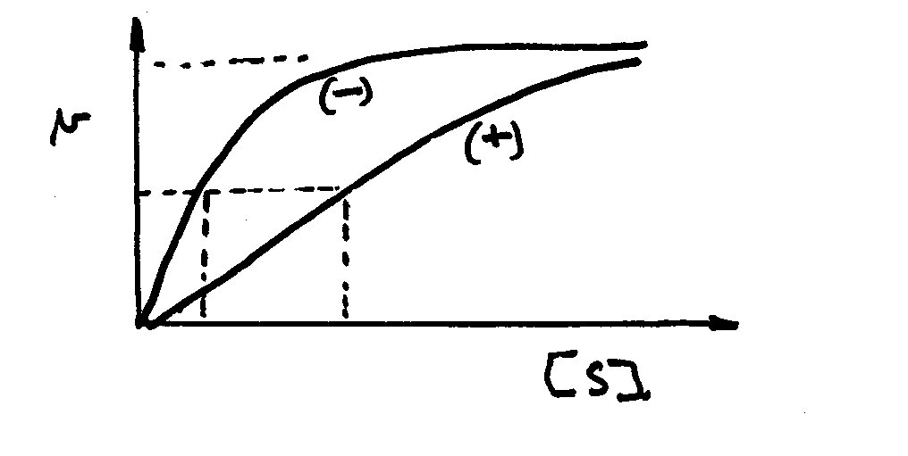
F. remains constant, decreases.

48. The following graph shows the reaction kinetics in the presence (+) and absence (—) of an inhibitor. The inhibitor is
- competitive.
- noncompetitive.

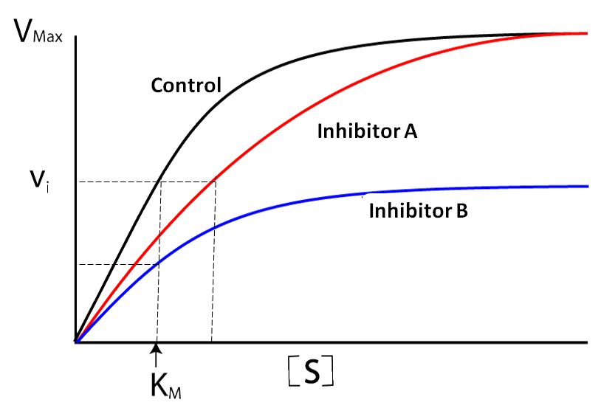
Question 49 and 50: see Figure.

49. (See Figure Q50) The following graph shows the reaction kinetics in the presence (Inhibitor A or Inhibitor B) and absence (control) of an inhibitor. The inhibitor B is
- competitive.
- non-competitive.

50. In the following graph the kinetics of the uninhibited reaction is indicated by control and that of the inhibited reaction by Inhibitor A o rinhibitor B. What function identifies a competitive inhibitor?
A. or B.

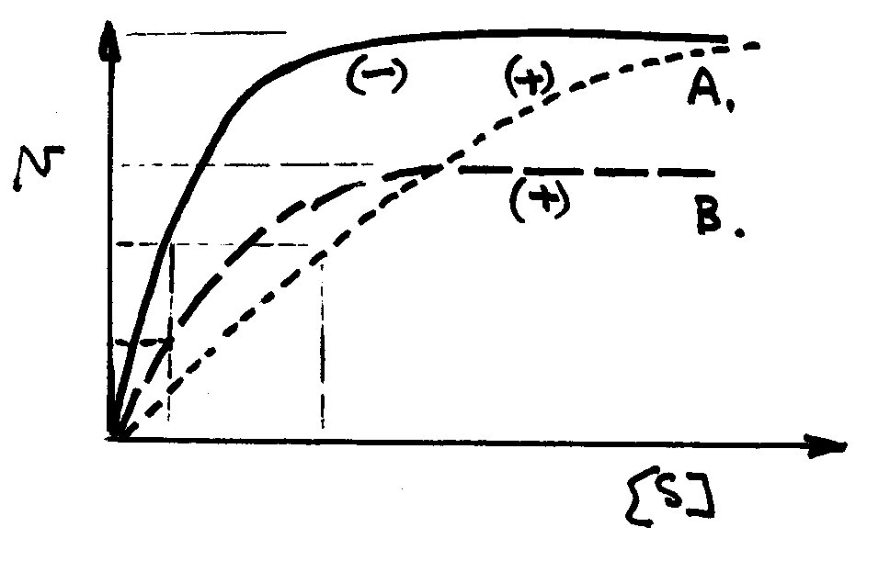
50a. In the following graph the kinetics of the uninhibited reaction is indicated by (-) and that of the inhibited reaction by (+). What function identifies a competitive inhibitor?
A.
B.

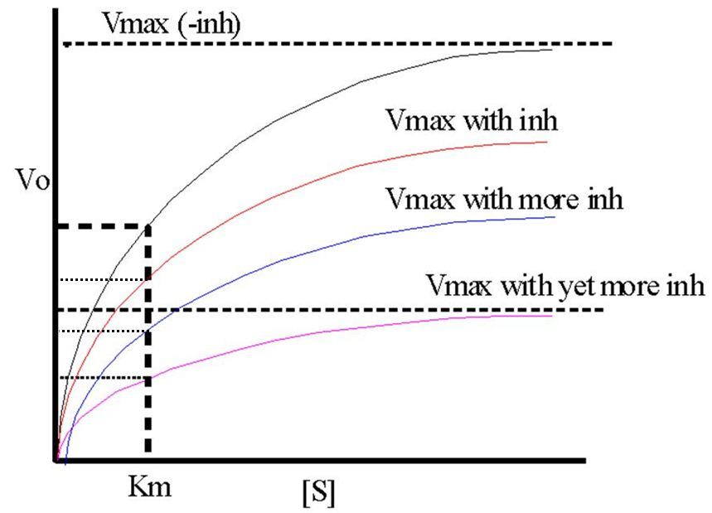
50b. The following graph represents:
- a competitive inhibitor.
- A non-competitive inhibitor.

- Most components of energy conversion systems evolved very early; thus, the most fundamental aspects of energy metabolism tend to be:
A. quite different among a diverse group of organisms.
B. very different among plants and animals.
C. the same among the autotrophs but different among heterotrophs.
D. the same among prokaryotes but different among eukaryotes.
E. very similar in a wide range of different organisms.

- The ultimate source of energy for almost all living organisms is:
A. heat.
B. glucose.
C. carbohydrates.
D. lipids.
E. the sun.

- The sum of all chemical activities taking place in an organism is:
A. anabolism.
B. catabolism.
C. metabolism.
D. dehydration synthesis.
E. condensation reactions.

- Which of the following accurately represents the relationship between the terms anabolism, catabolism, and metabolism?
A. anabolism = catabolism
B. metabolism = catabolism
C. catabolism = anabolism + metabolism
D. anabolism = catabolism + metabolism
E. metabolism = catabolism + anabolism

- Catabolic reactions involve the:
A. breakdown of large organic molecules to simple building blocks.
B. breakdown of life sustaining processes within cells.
C. building up of complex organic molecules from simple building blocks.
D. anabolic production of complex molecules.
E. expenditure of energy.

- Pathways that have an overall energy requirement are referred to as:
A. catabolic reactions.
B. anabolic reactions.
C. energy-releasing reactions.
D. energetically feasible reactions.
E. reactions that will proceed spontaneously.

- Every type of chemical bond contains a certain amount of energy. The total bond energy, which is essentially equivalent to the total potential energy of the system, is a quantity known as:
A. entropy.
B. kinetic energy.
C. thermodynamic energy.
D. enthalpy.
E. free energy.

- An endergonic reaction can proceed only if it absorbs:
A. more free energy than is released by a coupled exergonic reaction.
B. less free energy than was released by a coupled endergonic reaction.
C. less free energy than is released by a coupled exergonic reaction.
D. the same amount of free energy that is absorbed by the enzymatic breakdown of proteins.
E. energy from ADP, forming ATP.

- In a reaction in which the rate of the reverse reaction is equal to the rate of the forward reaction, a state of ____________ is attained.
A. total entropy
B. enthalpy
C. thermodynamics
D. dynamic equilibrium
E. product reversibility

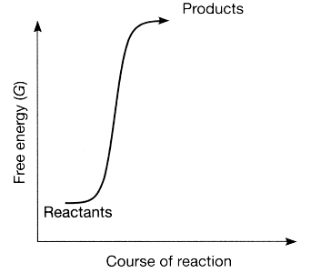
72, 73. Use the figure to answer the corresponding questions.

- Which of the following statements about the accompanying figure is true?

A. The reactants have more free energy than the products.
B. The products have more free energy than the reactants.
C. The figure represents a spontaneous reaction.
D. The figure represents an endergonic reaction.
E. The reaction is endergonic, and also the products have more free energy than the reactants.

- Because enzymes affect the speed of chemical reactions without being consumed, they are referred to as:
A. hydrogen acceptors.
B. activation energy.
C. catalysts.
D. cytochromes.
E. transformation proteins.

- Which of the following statements concerning enzymes is FALSE?
A. Each enzyme has an optimal temperature.
B. Each enzyme has an optimal pH.
C. Most enzymes are highly specific.
D. Some enzymes require cofactors.
E. Most enzymes are RNA molecules.

- Enzymes are important biological catalysts because they:
A. supply the energy to initiate a biochemical reaction.
B. increase the free energy of a biochemical reaction.
C. lower the entropy of a biochemical reaction.
D. decrease the enthalpy of a biochemical reaction.
E. lower the activation energy of a biochemical reaction.

64. Which of the following statements concerning activation energy is FALSE?
A. Exergonic reactions have an energy of activation.
B. Endergonic reactions have an energy of activation.
C. Enzymes lower a reaction’s activation energy.
D. Catalysts raise a reaction’s activation energy.
E. Activation energy is the energy required to break existing bonds.

Use the figure to answer the corresponding questions.

65. The line on the graph labeled B represents the:
A. activation energy with an enzyme.
B. activation energy without an enzyme.
C. free energy of the reactants.
D. change in entropy.
E. change in enthalpy.

- The line on the graph labeled C represents the:
A. activation energy with an enzyme.
B. activation energy without an enzyme.
C. change in free energy.
D. change in entropy.
E. change in enthalpy.
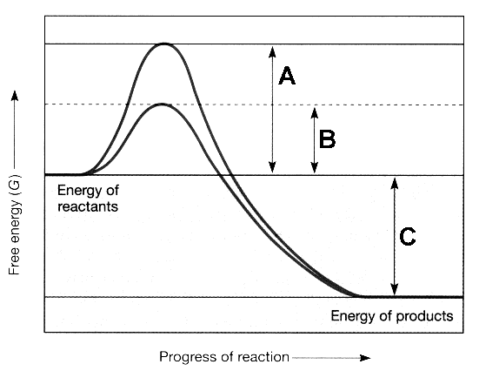

- Parts of the enzyme molecule that interact with a substrate are called:
A. cofactors.
B. active sites.
C. induced-fit models.
D. orientation sites.
E. reaction sites.

- The substance on which an enzyme acts is called the:
A. substrate.
B. product.
C. ATP.
D. free energy.
E. cofactor.

- What refers to the situation in which the binding of a substrate to the enzyme causes a change in the enzyme’s shape, facilitating an enzyme’s function?
A. active site
B. cofactor
C. activation energy
D. induced fit
E. allosteric inhibition

- Hydrolases are one important class of enzyme that function to catalyze:
A. splitting a molecule using water.
B. conversions between isomers.
C. reactions in which double bonds are formed.
D. oxidation-reduction reactions.
E. none of these.

- Which refers to an organic, nonpolypeptide compound that binds to the apoenzyme and serves as a cofactor?
A. coenzyme
B. catalyst
C. substrate
D. mineral
E. allosteric regulator

- Which of the following does not represent a method by which cells regulate enzyme activity?
A. controlling the intracellular concentration of the enzyme
B. feedback inhibition of enzymes
C. the binding of allosteric regulators to allosteric sites on the enzyme
D. differential gene expression of the genes that produce enzymes
E. heat denaturation of the enzyme

- Select the enzyme that does not match the reaction:
A. sucrase—splits sucrose into glucose and fructose
B. lipase—breaks ester linkages
C. phosphatase—removes phosphate groups
D. urease—converts urea to ammonia and CO₂
E. kinase—breaks peptide bonds

- If one continues to increase the temperature in an enzyme-catalyzed reaction, the rate of the reaction:
A. does not change.
B. increases and then levels off.
C. decreases and then levels off.
D. increases and then decreases rapidly.
E. decreases and then increases rapidly.

- You conduct an experiment in which you add increasing amounts of substrate to an enzyme solution and then measure the resulting reaction rate. You graph your results, plotting the rate of the reaction on the Y-axis versus substrate concentration on the X-axis. What do you conclude from your graph?
A. The reaction rate is directly proportional to substrate concentration.
B. The reaction rate is independent of substrate concentration.
C. The reaction rate increases but then decreases, forming a bell-shaped curve.
D. The reaction rate decreases with increasing substrate concentration.
E. The reaction rate increases with increasing substrate concentration up to a point, above which the rate remains constant.

- An allosteric enzyme:
A. has an active site that binds to the substrate and an allosteric site that binds to the product.
B. allows the movement of molecules and ions from one part of the cell to another.
C. catalyzes both oxidation and reduction reactions.
D. raises a reaction’s activation energy so that the rate of the reaction declines.
E. allows a substance other than the substrate to bind to the enzyme, thereby activating or inactivating it.

- Competitive inhibitors inhibit biochemical reactions in such a way as to seemingly:
A. increase the concentration of substrate.
B. reduce the concentration of enzyme.
C. increase the concentration of enzyme.
D. reduce the concentration of substrate.
E. denature the enzyme.

- Penicillin is a drug that acts by:
A. irreversibly inhibiting transpeptidase.
B. reversibly inhibiting transpeptidase.
C. competitively inhibiting transpeptidase.
D. noncompetitively inhibiting transpeptidase.
E. none of these.

- A reaction that requires a net input of free energy is described as

- Exergonic
- Endergonic
- Spontaneous
- Both a and c
- Both b and c

- A reaction that releases energy is described as
- Exergonic
- Endergonic
- Spontaneous
- Both a and c
- Both b and c

- A spontaneous reaction is one in which the change in free energy (ΔG) has a __________ value.
- Positive
- Negative
- Positive or negative
- None of these (ΔG has no measurable value)

- To drive a reaction that requires an input of energy,
- An enzyme-substrate complex must form
- The concentration of ATP must be decreased
- The activation energy must be increased
- Some reaction that releases energy must be coupled to it
- Some reaction that requires energy must be coupled to it

- Which of the following reactions could be coupled to an endergonic reaction with ΔG= + 3.56 kJ/mol?
- A B, ΔG=+6.08 kJ/mol
- C C, ΔG=3.56 kJ/mol
- E F, ΔG= 0 kJ/mol
- G H, ΔG=-1.22 kJ/mol
- I J, ΔG=-5.91 kJ/mol

- Consider the reaction: Glucose + 6 O2 6 CO2 + 6 H2O (ΔG= -2880 kJ/mol). Which of the following statements about this reaction is not true?
- The reaction is spontaneous in a thermodynamic sense
- A small amount of energy (activation energy) must be supplied to start the reaction, which then proceeds with a release of energy
- The reaction is exergonic
- The reaction can be coupled to an endergonic reaction
- The reaction must be coupled to an exergonic reaction

- The energy required to initiate a reaction is called
- Activation energy
- Bond energy
- Potential energy
- Free energy
- Heat energy

- A biological catalyst that affects the rate of a chemical reaction without being consumed by the reaction is a(an)
- Product
- Cofactor
- Coenzyme
- Substrate
- Enzyme

- The region of an enzyme molecule that combines with the substrate is the
- Allosteric site
- Reactant
- Active site
- Coenzyme
- Product

- Which inhibitor binds to the active site of an enzyme
- Noncompetitive inhibitor
- Competitive inhibitor
- Irreversible inhibitor
- Allosteric regulator
- PABA

- In the following reaction series, which enzyme(s) is/are most likely to have an allosteric site to which the end product E binds?
- Enzyme 1
- Enzyme 2
- Enzyme 3
- Enzyme 4
- Enzymes 3 and 4

True/False

- Chemical energy is a form of kinetic energy. __________________
- A closed system does not exchange energy with its surroundings. _________________
- According to the second law of themodynamics, energy cannot be created nor destroyed.____

- The conversion of polysaccharides to monosaccharides is an example of an anabolic reaction._______

- In the equation H = G + TS, the H stands for free energy. __________________

- An exergonic reaction results in a net gain of free energy. __________________

- A cell must expend energy to produce a concentration gradient. __________________

- ATP is a type of nucleotide. __________________

- The cell maintains a ratio of ATP to ADP that is at the equilibrium point. __________________

- FAD becomes oxidized when it accepts hydrogen atoms and their electrons. _____________

- An enzyme raises the activation energy of the reaction it catalyzes. ________________

- An enzyme binds its substrate at the active site. __________________

- Most vitamins are coenzymes. __________________

- At a constant temperature and pH, the rate of an enzymatically catalyzed reaction is inversely proportional to the enzyme concentration. __________________

- In competitive inhibition, the inhibitor binds to the enzyme at the allosteric site. _____________

