Math 217, LAB 1: GETTING STARTED WITH SPSS

The purpose of this lab is to learn how the windows of SPSS are organized, how to read the information displayed, and how cases and variables are organized. You will also learn how to create and interpret frequency tables and (briefly) histograms.

1. Starting SPSS

An SPSS session can be opened like any other Windows-based program. Click and hold the Start button. From the Programs menu choose SPSS 11 followed by spsswin. The SPSS program will open, and you should see the dialog box shown below.

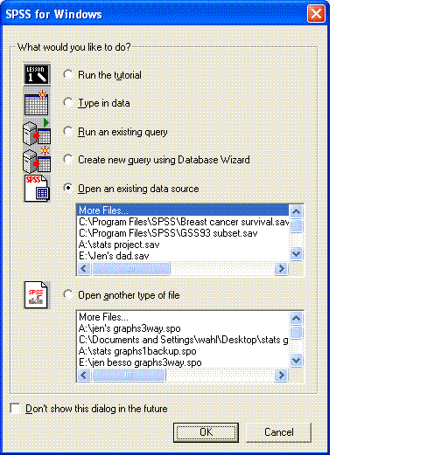

You will notice that you have several choices, including creating a new SPSS document or accessing more files. In the upper box, you see the words More Files… and then the list of SPSS files that have been opened recently. If the file you want is not in this list, select More Files… by clicking on it and then click OK. You get the dialog box shown below.

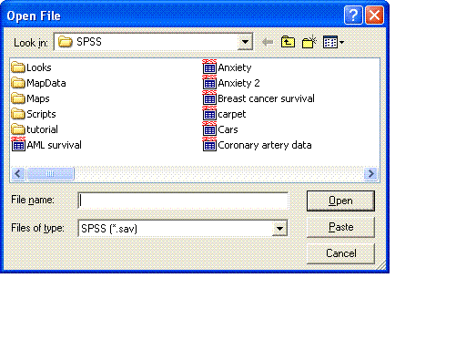
The dialog box gives you a list of the available files. We are going to work on the GSS93 subset file; double-click on it. You should now get the GSS93 subset data window open, as shown below.

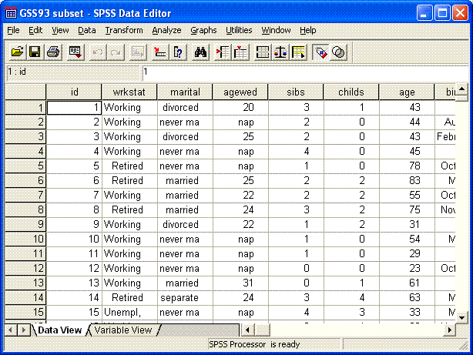

Every time you open an SPSS data file, you get what is called an SPSS Data Editor. It can appear in one of two views: a Data View and a Variable View. At the bottom left of the SPSS window, you see two little tabs that allow you to display one or the other of the two views. Try clicking on Variable View; you should obtain a window like the one shown below.

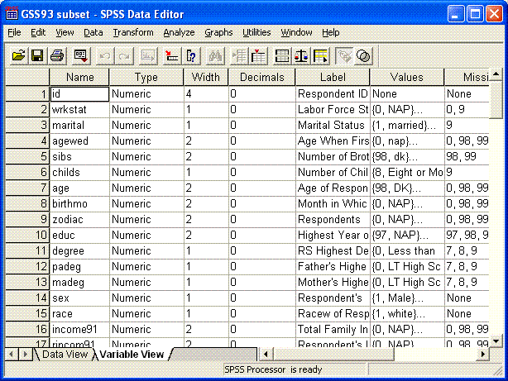

In this view, every row contains the information that pertains to one variable. We will explain this information after we look at the other view, the Data View.

When you click on the Data View tab of the SPSS Data Editor, you see the data itself, and you can modify it directly in this window. Perform the operations indicated below and observe their effects on the screen.

- Get SPSS to display the Value Labels instead of the codes by selecting Value Labels under View.
- Read the full name of any variable by pointing the mouse on the short name at the top of any column.
- Enlarge any column by positioning the mouse right on the edge separating the variable names, and drag slightly to the right.
- Select Variables under the Utilities menu. You will get the dialog box shown below. By scrolling down the list of variables, you will be able to see the detailed description of each variable, one at a time.

You will see:
- The Variable Label (which is the long version of the name)
- The type and the missing values
- The Value Labels, and their corresponding codes
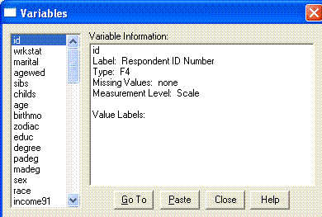

- The Type. This is the format of the numerical values or labels you enter. For example, F1 means that the format used for that variable is one space long, with no decimals. F5.2 means that 5 spaces are reserved to write the values of that variable, of which 2 are decimals (like 123.45).
- Missing Values. For each variable, some of the answers should not be taken into account in the statistics, such as when somebody refuses to answer, or when the question does not apply to that person. We give codes for the values ‘Refuses to answer’ and ‘Does Not Apply’, but we must indicate that these answers are not to be treated like the other answers. We label them “missing values.”
- Measurement Level. In this data file, the variable Marital Status has been defined to be ordinal, meaning it is a categorical variable whose categories have a natural ordering. The proper measurement level for this variable should have been nominal. Sometimes, however, nominal variables are labeled Ordinal to allow SPSS to perform certain operation that can be done only on ordinal or on numerical scales. Quantitative variables, like age, should be labeled Scale.

Here is your assignment:
- Read the beginning of the SPSS online tutorial (go to the “help” menu and choose tutorial). Read the basic introduction up through the section on creating a frequency table, then go back to the GSS93 subset data file.

- Create frequency tables to answer the following four questions about the subjects in the GSS93 subset data file.

- What percentage of the respondents are male? _____ Female? _____
- Find an age so that half the sample are younger than that age, the other half being older: ____________
- What percentage of the respondents (of those who answered the question) believe marijuana should be made legal? ________
- What percentage of the respondents are married? ______ divorced? _______

  - Only a “scale” (quantitative) variable can be used to generate a histogram. For some reason, almost all the variables in GSS93 subset have been designated as “ordinal” variables – many of them erroneously.

  - Choose “Variable View” by clicking on the appropriate tab (lower left). Locate the variable “age” (Age of Respondent). Change it from ordinal to scale.

  - Choose “Data View.” From the “Graphs” menu choose interactive > histogram …

  - Create a histogram of the variable “age”. It should display “count” on the vertical axis. Write a brief paragraph to describe the distribution of the variable “age” in the GSS93 dataset. Pay attention to overall shape (how many major peaks? symmetrical? skewed?), center (what’s the middle age?), spread (minimum and maximum ages?), and look for outliers (do any folks have highly “unusual” ages compared to other respondents?).

In the my documents folder on your computer, create a new folder with your name. Make a habit of using the same computer as much as possible throughout the term.

Save a copy of your SPSS output file to the folder you created. It should contain your frequency tables and histogram. Name it “Lab 1,” for example, so you can distinguish it from future labs. This is a good place to save a copy of all your SPSS work this term in case you have a problem with your disk, CD, etc.

Write the number of your computer here _________ .

Turn in this handout, with written answers, by the due date for Lab 1 (see your Math 217 schedule).

