**Math 121C**

**10-26-11**

**Chain Rule Practice**

Directions:

* Work independently, or with a partner (whichever is best for you).
* For each function *y*, find the derivative,.
* For each function *y*, find *all* real number solutions to the equation. (What do these *x* values correspond to on the graph of *y*?)

1. 

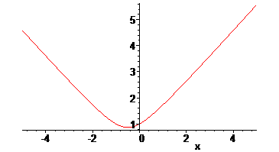

1. 

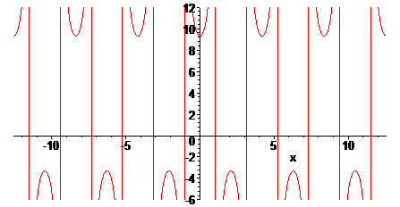

1. 

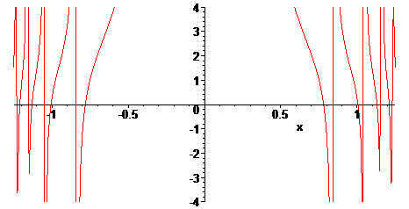

1. 

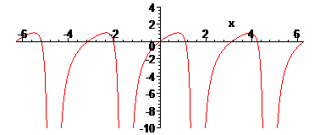

1. 

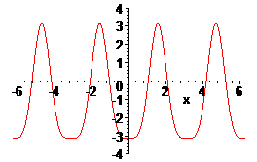

1. 

