You may use the extra sheets of paper to solve the following questions, but please report the results and conclusions in the space provided. Whenever possible, show your work for potential partial credit. NOTE: When performing numerical calculations, keep at least 4 digits after a decimal. (i.e., do NOT round .2265 to .23 or .227) BUDGET TIME WISELY!
1. The following data set provides information about eight shoppers at Wal-mart.
Name | Number of children | Age | Convicted Felon? | Method of Payment (cash=0, check=1, credit=2)
Jake | 0 | 28 | No | 0
Nick | 2 | 65 | No | 1
Meagan | 4 | 46 | Yes | 0
Rachel | 2 | 52 | No | 0
Sara | 1 | 19 | Yes | 1
a. How many elements, variables and observations are in this data set? (3 points)

b. Which of the variables in this data set are qualitative and which are quantitative? Explain. (5 points)

c. For each variable, which measurement scale is being used? Explain. (5 points)

2. A marketing research company has surveyed a parking lot outside of a local Wal-mart in Madison, Indiana and recorded the types of cars in a random sample. What is the population being studied? Use this graph to make two specific statistical inferences. (12 points) 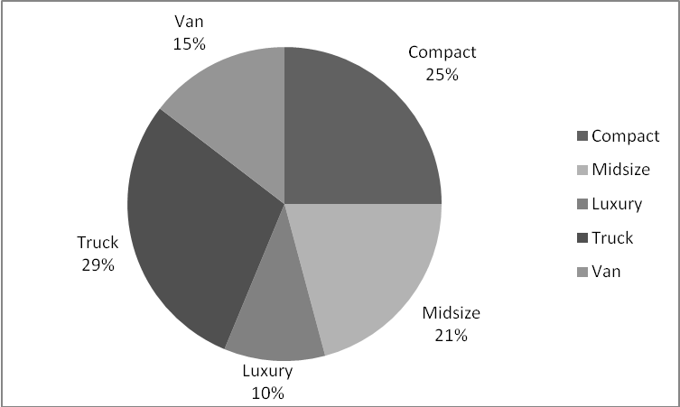
3. Data has been collected for a sample of six college students who were surveyed and asked their cumulative GPA and the typical number of hours that they study each week outside of class. The data are presented in the table below.
Student | GPA | Study Hours
1 | 3.17 | 7.5
2 | 3.2 | 30
3 | 3.2 | 30
4 | 3.01 | 24
5 | 3.56 | 20
6 | 3 | 14

a. Calculate the mean and median of only the GPA variable. Interpret this mean and median. (4 points)

b. Calculate the standard deviation of the GPA variable. Interpret this value. (6 points)

c. The sample covariance between GPA and Study Hours .145. What does this value tell us? (3 points)

d. The mean number of hours studied is 20.92 with a standard deviation of 8.98. Calculate the sample correlation coefficient between GPA and Study Hours. What does this value tell us? Does it make sense? Explain. (6 points)

e. Suppose the distribution of all Hanover student GPAs looked like a bell-shaped curve. Use the information calculated above, and the Empirical Rule, to determine specific values of GPA that would include approximately 95% of all GPAs. How would you use the Empirical Rule to investigate outliers in any data set? Explain. (6 points)

4. A survey of magazine subscribers showed that 45.8% rented a car during the past 12 months for business reasons, 54% rented a car during the past 12 months for personal reasons, and 30% rented a car during the past 12 months for both business and personal reasons.
a. What is the probability that a subscriber rented a car during the past 12 months for business or personal reasons? (6 points)

b. What is the probability that a subscriber did not rent a car during the past 12 months for either business or personal reasons? (5 points)

5. A statistics survey has tried to measure the relationship between gender and drinking. The event A is that a student claims to drink alcohol in a typical week. The event F is that a student is female and the event M is that the student is male.
 | A | A^{c} | Totals
F | 51 | 46 | 97
M | 70 | 23 | 93
Totals | 121 | 69 | 190

Are drinking and gender independent events? Are they mutually exclusive? Explain and demonstrate with probabilities. (8 points)

6. For each of the following experiments, identify whether the random variable is discrete or continuous. Then give the values that the random variable x can take. (6 points)
Experiment | Random variable (x) | Discrete or continuous? | Values that x can take.
Test 10 patients for strep throat. | Number of patients that test positive for strep throat.
Drive a 10-mile length of highway. | Number of dead “road kill” animals observed along the road.
Survey 100 weekday commuting workers at a parking garage. | Number of miles from the worker’s home to the parking garage.

7. A car salesperson knows from experience that if he has 40 people shopping for cars, he will sell 10 of those cars. On the last day of the month, he has 10 people shopping for cars. He needs to sell at least 3 cars to make his monthly rent payment.
a. What is the probability that he will not be able to make his monthly rent payment? (5 points)

8. The time, in minutes, that it takes a truck driver to complete a delivery route follows an exponential probability distribution with a mean of 410 minutes.
a. The driver’s contract has a system of daily bonuses if the deliveries are made in a relatively short period of time and a system of daily penalties if the deliveries take an egregiously long time to complete. For example, if the daily deliveries are made in fewer than 330 minutes, the driver will receive a $50 bonus on top of his daily wage. If it takes longer than 450 minutes to complete the daily deliveries, the driver will be docked $30 from his daily wage. If the driver works 25 days per month, how much additional money will he expect to gain, or lose, with this system of bonuses and penalties? Show your work. (5 points)

b. Your nosy roommate wants you to calculate the probability that the deliveries are completed in exactly 510 minutes.. What do you say to your roommate? Explain your reasoning. (6 points)

9. Assume the Hanover College student grade point average is normally distributed with a population mean of 3.0576 and population standard deviation of .5892.
a. What is the probability that a randomly selected student will have a GPA below the Dean’s List of 3.50 and above a GPA of 2.00? (4 points)

b. At what GPA would a student need to earn such that he/she would have a GPA at the 99th percentile of the student body? (5 points)

